GRADE 5 – FEBRUARY FITNESS FRIDAYS- FUNDRAISER
Feeling blah from winter blues or recovering from the holidays!
Come join us for a great fun hour of Zumba hosted by the marvelous Silvi owner of Latin Fitness Ztudio in Bby. Open to child 5 yrs+ and parent. All kids must be accompanied by a parent.
GREAT MUSIC AND LOTS OF FUN!
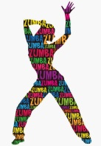
Date: Feb. 16, 2018
Time: 6:30-7:30pm in the Rochester Gym
Price: $10/person payable at the door
Latin Fitness Ztudio
A-5595 Kingsway (at McPherson)
Burnaby, BC V5H 2G5 Canada (map)
(604) 354-9426
info@latinfitnessztudio.com

